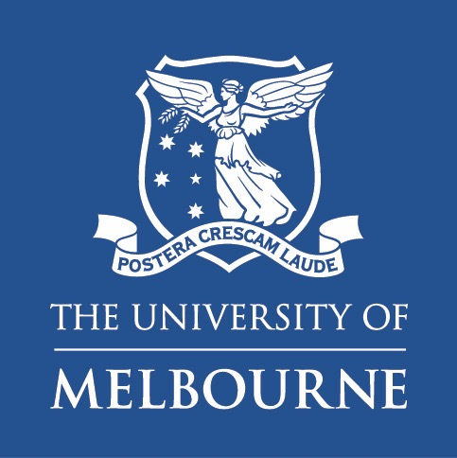 | Faculty of Arts  School of Languages and Linguistics  PhD Scholarship in Applied Linguistics

About the opportunity

We invite applications from suitably and highly qualified candidates for a PhD scholarship
in the Applied Linguistics discipline, with a specific focus on sociolinguistics issues. The PhD scholarship is part of a larger Australian Research Council DECRA project led by Dr Trang Nguyen. The aim of the DECRA project is to investigate migrant youth’s experiences and management of linguistic discrimination, and its impact on their linguistic citizenship, in the regional Australian context. The successful applicant must commence by 27 February 2023, and will be enrolled in the School of Languages and Linguistics, the University of Melbourne. The candidate will pursue an independent research project under the supervision of Dr Trang Nguyen and Professor John Hajek. The candidate will join the DECRA team and is expected to actively contribute to the wider project, while also responsible for the development of their own research agenda.

About the PhD project

The successful applicant will lead their PhD study that is relevant to the broad parameters of the wider project, and focuses on multilingualism and linguistic diversity in relation to culturally and linguistically diverse people (e.g., ethnic minorities or migrants). It will thereby make significant contributions to the field of sociolinguistics. Ideally, the PhD project may align with more than one of the following themes:

- Language and social justice
- Language, identity, and citizenship
- Language and intercultural/interethnic communication

The PhD candidate will be strongly supported to develop a high-quality PhD project and advance their research skills. Thus, they should have capacity to well perform and meet high expectations during their PhD candidature, including: actively participating in the wider project’s research and community activities while effectively undertaking an independent PhD thesis, exceling in working under pressure and dealing with strict deadlines, and directing their research towards excellent outcomes such as publishing papers in peer-review journals.

About you

* Essential criteria
You must:
- hold a Bachelor's Degree with first class honours OR a Master's Degree - with a substantial research component in a related field (e.g. applied linguistics, TESOL, anthropology, or sociology of language/ethnicity/migration, etc). Applicants who already hold a PhD or are currently completing a PhD will not be considered.
- meet the entry requirements for the Doctor of Philosophy – Arts by the University of Melbourne, including English-language proficiency skills (refer here: https://study.unimelb.edu.au/find/courses/graduate/doctor-of-philosophy-arts/entry-requirements/).
- have an outstanding academic record and research achievements since graduation.
- have excellent English academic writing and communication skills.

* Desirable criteria

You should:

- have qualities necessary for doing research, including: being focused, highly motivated and self-regulated, and working hard.
- be able to work independently and work in a team.
- have knowledge about research methodologies in humanities and social sciences, including qualitative methodologies.
- have established relationships and networks with potential research subjects which you intend to target for your PhD project, as well as with the community in which they live.
- have experience of or be familiar with one or more than one research theme mentioned in the “About the PhD Project” section.
- have publication experience (this will be a plus to your application).

About the scholarship

- Full fee offset for up to four years;
- Living allowance of $34,400 per year pro rata (2023 full-time study rate) for up to 3.5 years (conditions applied); and
- Other benefits as per the Graduate Research Scholarship Terms and Conditions.

The successful applicant is expected to be enrolled full time and on campus for the duration of their candidature.

Application Procedure

Please submit an expression of interest form to Dr Trang Nguyen [trang.nguyen9@unimelb.edu.au] no later than 25 November 2022, alongside the following documents:
- A cover letter (up to 3 pages) that sets out why your background, skills, and interests make you a strong candidate for this position. You are also expected to address the desirable criteria (mentioned in the “About you” and “About the PhD project” sections).
- A brief research proposal (up to 2,500 words), outlining preliminary ideas, problem statement, brief literature review (if necessary), research questions, and methodology.
- A writing sample (up to 5000 words).
- Thesis examiners' reports (if applicable).
- A current CV (or Resume) outlining all your complete and incomplete academic qualifications and work experience, details of any research publications (if relevant) (up to 5 pages).
- Academic transcripts.

The selection of applicants will involve consideration of your academic merit and research background. Only shortlisted candidates will be interviewed.

Submission deadline is 25 November 2022. Submissions may be closed before the deadline once a suitable candidate is selected. Outcomes of the selection process is planned to be in January 2023. If successful, you will be invited to apply for an official admission through the Faculty of Arts’ process. Please note that we will not be able to provide feedback on unsuccessful applications.

Enquiries

Research/project enquiries: Dr Trang Nguyen: trang.nguyen9@unimelb.edu.au

Eligibility/admission enquiries: arts-gr@unimelb.edu.au

